Karen Backes, MSW • Academic Programs Coordinator II • backes@wustl.edu • (314) 935-5978
Tyler Stallings, MA • Academic Programs Coordinator II • tyler.s@wustl.edu • (314) 935-4989
Arianna Varela, MSW • Graduate Fellow 2025-2026

learningcenter.wustl.edu
Academic Skills Peer Coaching Handbook
The Learning Center at Washington University in St. Louis • Fall 2026

Table of Contents
Description of Position and Expectations 2
Coaching Process and Philosophy 3
What is (and isn’t) Academic Coaching? 3
Coach Approach Model 4
Open-Ended Questions 6
The Metacognition Cycle 7
Coaching with Understanding Model 8
Asset-Based Thinking 9
See-Think-Feel Awareness Tool 9
Self, Others, Situations (SOS) Awareness Tool 10
Theories on Learning and Student Development 11
Marcia Baxter Magolda’s Self-Authorship 11
Lev Vygotsky’s Zone of Proximal Development 11
Teresa Amabile and Steven Kramer’s Progress Theory 12
70-20-10 Approach to Learning​ 12
Communication, Setting Expectations, and Boundaries 13
Effective Communication Strategies 13
Defining the Coaching Relationship 14
Students Who Have Been Referred to Peer Coaching 15
Building Rapport 16
Universal Needs and Feelings 16
Self-Disclosure 17
Icebreaker Questions & Activities 17
Inclusive Facilitation & Bias Considerations 18
Specific Support and Strategies 20
Setting Goals 20
Time Management 22
Memory and Time Management 25
Canvas Calendar Feed 26
Study Strategies 27
Note Taking 29
Reading 31
Growth Mindset 33
Managing Procrastination 35
Reflection 37
Addressing Test Anxiety 39
Strategic Use of Generative AI 41
Supporting Neurodivergent Students 42
Academic Support Ecosystem: Resources & Referrals 43
Other Learning Center Resources 44
The Center for Teaching and Learning 44
Campus Resource Directory 45

Description of Position and Expectations
The primary role of an Academic Skills Peer Coach is to support undergraduate and CAPS students as they navigate university life. Peer Coaches help foster a collaborative academic community at WashU and help sustain student success. Coaches meet one-on-one with students in need of general academic support beyond specific courses, in addition to participating in group workshops throughout the semester. In a broader sense, the Peer Coach position is a challenging and rewarding experience that provides many opportunities to develop knowledge and skills in areas such as communication, group facilitation, evidence-based study strategies, and more.
Peer Coaches typically work 2-4 hours per week, offering 30-minute one-on-one sessions with students. Between appointments, coaches may work on other tasks related to the position, such as preparing presentations or creating new resources. Post-assessment forms must also be completed between sessions,
and staff may follow up with students after meetings.
Peer Coaches are required to attend technical training regarding booking and schedule changes and are expected to manage these in coordination with staff throughout the semester. Coaches should review the separate training manual thoroughly for Workday logistics. The Learning Center also offers a 1-credit seminar course for new Peer Coaches each fall semester, through which coaches learn best practices in coaching and apply strategies with their cohort during weekly meetings. This course is required for professional development, and coaching sessions will begin in tandem. The seminar course also hosts presentations and Q&A sessions featuring key campus partners.
The following outline offers the foundation for The Learning Center’s Academic Skills Peer Coaching program. It also serves a dual purpose for coaches as a customizable document during the Fall seminar course. Coaches will access a digital version to create an individual workbook adding notes, prompts, scenarios, etc. This active and expansive learning will complement the course syllabus and reiterate this outline as a pedagogical tool.

Coaching Process and Philosophy

What is (and isn’t) Academic Coaching?
The Learning Center’s approach to Peer Coaching is heavily influenced by the Coach Approach model developed at the University of North Carolina Chapel Hill. According to this model, academic coaching is defined as a collaborative and trusting relationship that empowers students to understand, develop, and improve their own goals, habits, thinking patterns, strengths/weaknesses, self-regulation, academic skills, and metacognition.
Coaching is distinct from other approaches to personal and professional development, such as mentoring, advising, and counseling:
- Coaching emphasizes personal growth through structured support by helping individuals identify goals, explore challenges, and develop action plans.
- Mentoring fosters relationships for long-term development and guidance based on personal experience, insights, and knowledge.
- Advising offers expertise to guide decision-making.
- Counseling is primarily concerned with mental health and emotional well-being.
Coaching is not therapy, but it can have a therapeutic effect.
Your role as a Peer Coach is to help students develop their academic skills and build habits that help them succeed. Many learning barriers are multifactorial, and you are not expected to address your peers’ mental or physical health, nor their personal issues.
Jot some notes below about the Peer Coach role and its overlap with other roles. If you prefer thinking visually, consider a Venn diagram:

Coach Approach Model
UNC Chapel Hill’s Coach Approach Model is the foundation of the Learning Center’s Peer Coaching program. It was developed by Kristin Rademacher and Marc Howlett in collaboration with Dr. Theresa Maitland, an expert on issues relating to college success of individuals with ADHD and other learning disabilities. This method of facilitating dialogue with students is built on five core beliefs and assumptions:
- Students are “naturally creative, resourceful, and whole.” They are not broken,
and they do not need to be fixed.
- Students are the experts on their own lives.
- The student, not the problem, is the focus of the conversation.
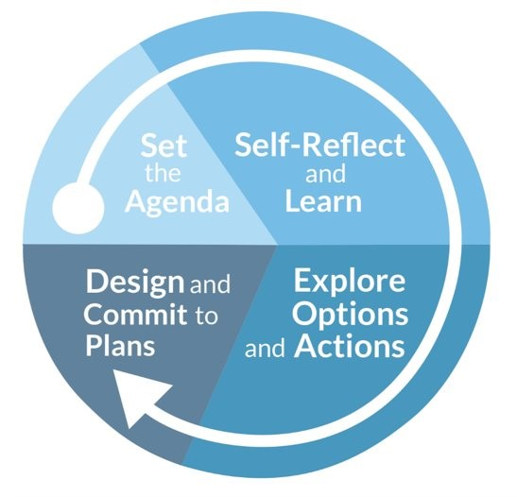
- Challenges are opportunities for growth.
- Coaching is collaborative.
Coaching conversations go through four phases, as illustrated by the graphic to the right. You will ideally spend most of your time in the Self-Reflect and Learn
and Explore Options and Actions phases.
This model uses four fundamental coaching tools
to facilitate conversations:
- Ask open-ended questions
- Be curious
- Listen fully
- Manage yourself

What comes to mind when you think about the four fundamental coaching tools and five core beliefs
and assumptions? How will you bring these tools and beliefs into your coaching sessions?

A similar conceptual framework is LACE:
Listen to understand; Ask power questions; Challenge and support; Establish next steps and accountability
Within a coaching conversation, coaches and students have distinct but complementary roles:
Student | Coach
Set agenda | Keep student focused on the agenda
Self-reflect | Ask questions to promote self-discovery
Explore opinions and ideas | Generate possibilities; evaluate and  broaden perspectives
Try out ideas; practice strategies | Provide guidance and feedback
Commit to using strategies independently | Ask questions to help develop a clear  action plan
Agree to be held accountable | Brainstorm accountability measures

In your own words, how would you describe your role as a Peer Coach? How do you see your role changing
as you move through the four steps of a coaching conversation?

Open-Ended Questions
The use of open-ended questions is fundamental to coaching, across virtually all models and approaches. An open-ended question cannot be answered with a simple “yes” or “no,” which facilitates deeper conversations between coaches and peers. Many open-ended questions begin with the words “who,” “what,” “when,” “where,” or “how,” or with sentence stems like “tell me about…” or “walk me through…”
While “why” questions are also open-ended, they are often interpreted as abrasive or accusatory, which may
be problematic in a coaching setting. Almost any “why” question can be rephrased to mitigate this effect; for example, instead of asking, “Why do you think you failed that exam?” a coach might say, “Tell me more about the exam” or ask, “What challenges did you encounter that kept you from getting the grade you expected?”

In the table below, generate a bank of open-ended questions that would fit well in each phase of UNC Chapel Hill’s Coach Approach model, and that you particularly like.
Phase 1: Set the Agenda | Phase 2: Self-Reflect and Learn
Phase 3: Explore Options and Actions | Phase 4: Design and Commit to Plans
Activity adapted from UNC Chapel Hill’s “My Favorite Questions” handout.

The Metacognition Cycle
Metacognition refers to awareness and control of one’s thinking and learning. This includes how to plan, monitor, and assess one’s understanding and performance. It is the key to self-directed learning, and it is not
a linear process; rather, it involves an ongoing process of planning, learning, and reflecting. To successfully implement the Coach Approach methodology, Peer Coaches are expected to familiarize themselves with the metacognition cycle, shown below.
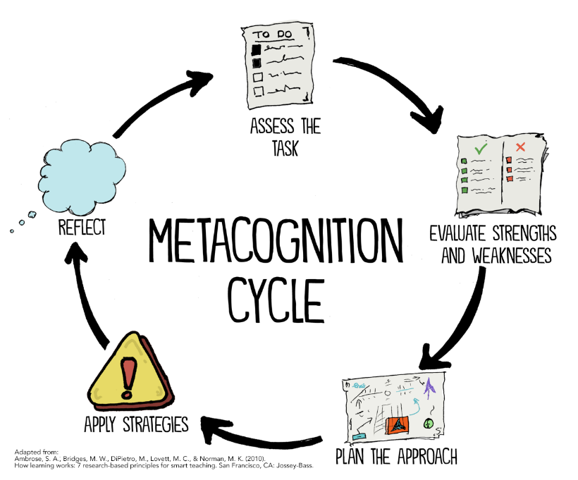
Using the example of a student preparing for a final exam, the five phases of the metacognition cycle may be understood as follows:
- Assess the Task: Establish what task is before them (final exam) and what they need to accomplish.
- Evaluate Strengths and Weaknesses: Take stock of the tools, skills, or experiences that may help them complete the task (e.g., they feel comfortable with most of the course material, and they have strong study skills) and those that may hinder their performance (they missed much of the final unit due to illness, and they have to study for another exam the same week).
- Plan the Approach: Decide how they will accomplish this task. For an exam, this might involve designing a study schedule, attending a review session, or seeking support from an academic mentor or professor.
- Apply Strategies: Put the plan into action! This step includes both the preparation for the hypothetical exam and taking the exam itself.
- Reflect: After completing the task, and especially after receiving feedback about their performance, the student should consider: Did they achieve their desired result? If so, what went well? If not, what didn’t go well, and how can they use this information to adjust their approach to similar tasks in the future?
Works consulted:
CIRCLE. (2018, September 24). Supporting social identity and inclusion: Metacognition. YouTube. https://www.youtube.com/watch?v=ykYQrjmmPV4
Spencer, J. (2018, August 13). Five ways to boost metacognition in the classroom. Spencer Education. https://spencereducation.com/metacognition/

Coaching with Understanding Model
This model, developed by former WashU Learning Center staff members Jay Sriram and Liz Gilmore, illustrates the relationships between four domains of experiences and behaviors that affect students’ academic performance. As seen in the graphic below, academic behavior (basic skills and habits) affects resource management (if and how students access support programs), which affects students’ mastery of metacognitive strategies (knowledge and application of more advanced, evidence-based skills). All three of these domains are affected by social/environmental factors, including a student’s social experience in college and their work/study/life balance.
Peer Coaches are encouraged to ask open-ended questions to learn more about their peers’ experiences and identify the domain(s) in which they are struggling. This information can help student-coach teams determine where and how to implement new strategies.
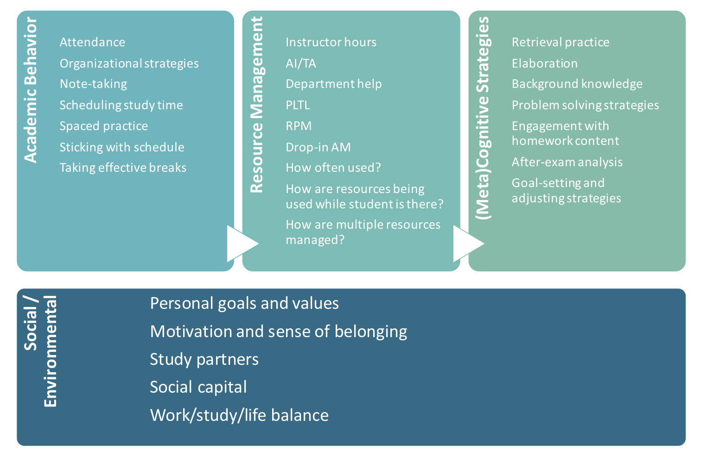
In the space below, brainstorm one question to ask about each domain in this model. Questions should be open-ended, single-barreled and not leading (i.e., the question is not asked in a way that implies a “correct” answer.)

Asset-Based Thinking
Asset-Based Thinking (ABT) is a simple mindset management process proven to promote greater resilience, optimism and confidence. Pioneered by psychologist Dr. Kathryn Cramer, ABT has shown people how to make small shifts in perception and thinking that have led to remarkable results in their work, their lives and the lives of those they touch.
Peer Coaches should promote ABT to help their peers retrain their attention to focus consistently on things that are working for them and what is possible, rather than things that are going wrong for them. The goal is to help students move away from shame and self-judgment, which are ineffective tools for self-improvement, towards positive emotional territory (i.e., curiosity, a sense of progress, hope, and confidence).
The differences between Deficit-Based Thinking and Asset-Based Thinking are outlined below:
 | Deficit-Based Thinking | Asset-Based Thinking
Focusing on… | - What you don’t want  - What you need  - What is problematic  - What you can’t do  - Who is against you  - What is holding you back  - What you stand to lose  - Your setbacks | - What you want  - What you have  - What is possible  - What you can do  - What is working  - Who is with you  - What is moving you forward  - What you stand to gain  - Your achievements
Leads to… | Self-criticism:  - Inner critic  - Exaggerates faults & mistakes  - Shame focused  - Devaluing of personhood  - Negative, problem- and  past-focused | Self-guidance:  - Appropriate guilt or remorse  - Focuses on what you could  be more skillful  - Positive, solution- and future action-focused

See-Think-Feel Awareness Tool
Coaches can use the following series of questions to help students examine and reframe their thinking:
- What am I seeing in myself, others, or this situation?
- What am I thinking as a result of what I see?
- How am I feeling as a result of what I am seeing and thinking?
Someone who is focused on a problem, or the downsides of a situation, may feel overwhelmed, whereas someone who is focused on the possibilities or upsides of a situation may feel excited and able to move forward.

Self, Others, Situations (SOS) Awareness Tool
The SOS Awareness Tool is a tangible way to break down and name areas to look for assets or strengths.
It is one way to do an “asset inventory.”
Self: Personal Assets (your own strengths and talents)
Can include your purpose, passion, resilience, courage, skills, subject matter expertise, emotional intelligence, confidence, commitment, ethics, etc.
Others: Relational Assets (what others can positively contribute because you are in community with them)
Can include collaboration, connectivity, mutual respect, creativity, empathy, trust, skills in giving and receiving feedback, resolving conflict, listening, advocacy, inspiration, etc.
Situations: Situational Assets (possibilities inherent in any situation, good or bad)
Can include challenges that could lead to breakthrough solutions, mistakes that will offer new insights
and learning, and opportunities and provide for innovation.

How do you see yourself incorporating Asset-Based Thinking and these communication tools into your
Peer Coaching sessions? What challenges do you anticipate?

What kinds of experiences or stressors might contribute to a student’s Deficit-Based Thinking? How would
you address them in your role, either directly or through referrals to other resources?

Theories on Learning and Student Development
Below are several theories which serve as a foundation to our support strategies. Understanding the premise
of each model is useful when applying communication techniques, refining academic skills, and encouraging agency of one’s learning.

Marcia Baxter Magolda’s Self-Authorship
“Self-Authorship is the internal capacity to define one’s beliefs, identity, and social relationships.”
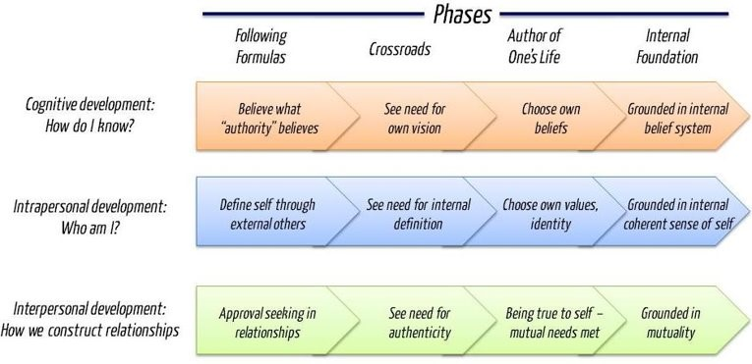
Read more: Self-Authorship: The Foundation for Twenty-First-Century Education (2007)

Lev Vygotsky’s Zone of Proximal Development
The zone of proximal development (ZPD) is a concept in educational psychology that describes the difference between what a learner can do independently and what they can do with help. It's also known as the zone of potential development. This is a constructivist model of learning which encourages attentiveness to an individual’s 9 development stage, bolstered by scaffolding. Peer Coaches are a form of scaffolding!
Mcleod, S. (2025). Vygotsky’s Theory of Cognitive Development. Simply Psychology. https://doi.org/10.5281/zenodo.15680745
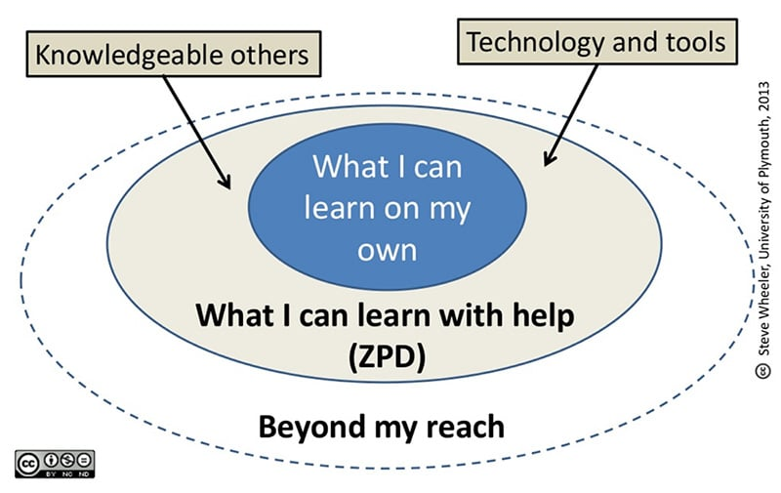

Teresa Amabile and Steven Kramer’s Progress Theory
The “progress loop” describes a positive feedback cycle which includes positive emotions, motivation, and perceptions. This loop suggests that experiencing progress, even in small steps, leads to increased engagement and motivation, which in turn fuels further progress.
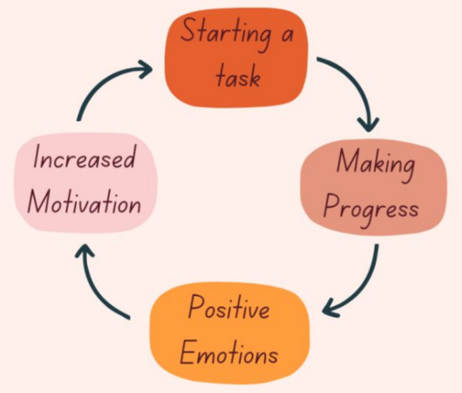

70-20-10 Approach to Learning​
Developed in the 1980s and gaining robust application in recent years, the 70-20-10 approach offers a strategic workplace learning framework. This model prioritizes experience, experiment and reflection, especially during challenging situations. Peer learning via collaboration and feedback is paramount.
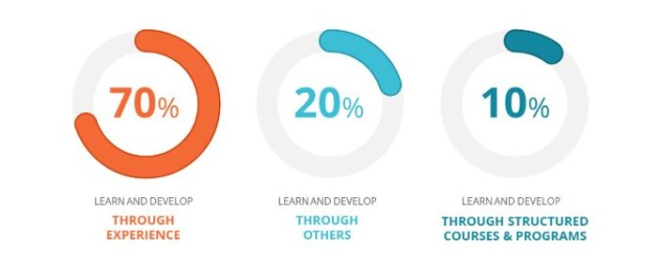
How do you relate to these theories on learning and student development? How are they useful in the context of your Peer Coaching role?

Communication, Setting Expectations, and Boundaries
Building trust and rapport is essential to a productive session. Below are useful considerations and strategies
to center the student, create engagement guidelines, and establish boundaries.

Effective Communication Strategies
According to Albert Mehrabian’s 7-38-55 theory, developed in 1971, 7% of meaning is communicated through spoken word, 38% through tone of voice, and 55% through body language. This means that while strong verbal communication is an essential component of a successful coaching relationship, non-verbal communication plays an even more significant role in establishing the dynamic between coach and student.
Non-verbal communication includes gestures, posture, facial expressions, tone, use of silence, and eye contact. All these cues, taken together, signal a person’s interest (or lack thereof) in an interaction or relationship. Peer Coaches should strive to maintain positive, open body language as described below:
Positive/Open | Negative/Closed
Eye contact (varies culturally, but often  seen as a sign of respect) | Averted eyes (unless mirroring other  party’s behavior or stated preference)
Relaxed, open posture | Crossed arms
Nodding and other affirmations | Tense posture
Pleasant facial expressions | Unpleasant (or even neutral)  facial expressions
Non-verbal communication is especially important for virtual sessions, where participants can only see each other’s faces and shoulders. Make sure your expression and upper body language are friendly and welcoming!
Regarding verbal communication, Peer Coaches can use a variety of strategies to facilitate productive conversations, including the following:
- Active Listening: Listening to process and understand, instead of listening to respond. Sometimes,
this means pausing for a moment to collect your thoughts before responding, and that’s okay!
- Reflecting / Paraphrasing: Repeating what a student has shared in your own words, in order to
make them feel heard and check your own comprehension of their story or priorities.
- Open-ended questions: Asking questions that cannot be answered with “yes” or “no.” See above
for more information.
- I-statements: Framing questions or statements in terms of your own observations, rather than making assumptions or judgments about the other speaker.
Common barriers to effective communication include jumping into problem solving too quickly, preaching, arguing, excessive talking or storytelling (on the part of the coach), and visible or audible impatience.

Defining the Coaching Relationship
Peer Coaches should begin every meeting by working with their peer to set an agenda. When meeting with
a student for the first time, part of this agenda should be to define the coaching relationship—what kind of support is the student looking for, and what can the coach provide?—and to design an alliance.
Professional coach Dr. Joy Zalis Kiefer defines a “designed alliance” as follows: It is the defined safe and courageous space we create between us with a clear understanding of what each of us is agreeing and committing to within the context of our learning relationship. It is a clear articulation of the way we want to
be in community with each other. To create psychological safety and inclusivity, it is important to make implicit norms and behavior explicit.
Here are some questions coaches may choose to ask themselves or their peers during an initial session:
- What is the service I provide? What is my role?
- What is the client’s role? Session attendance?
- How available am I outside of coaching sessions?
- If you could design me as your ideal coach, what qualities would be important to you? Can you agree
to tell me openly if I don’t live into those qualities?
- If I could design you as an ideal client, what qualities would be important to me?
- In the past, what has helped you hold yourself accountable? This is not a “classroom.” If you do
or don’t do the practices, I will ask you what you are learning.
- I value honesty and transparency. I will always come with my full curiosity, and I will tell you if something is not working. Can you commit to that also in this coaching relationship?
- If things are not progressing or things get difficult, how do you want me to be with that?
- Are there aspects of culture, heritage or other identities that you would like me to be aware of?
- Any questions you wish I would have asked you?
Given the time-limited nature of a typical Peer Coaching session, coaches should not expect to address all the above questions with every student they meet. However, they are encouraged to ask one or two of them if time permits, and they should be prepared to articulate their own expectations and values for coaching if asked.
What are your thoughts on the questions above? Which one(s) would you most like to ask during an initial coaching session?

Students Who Have Been Referred to Peer Coaching
While most Peer Coaching attendees seek out this resource and sign up for appointments voluntarily, some students may be encouraged or required to meet with a Peer Coach due to their affiliation with a specific course or organization, or their academic status (e.g., they are on Academic Action).
Whenever possible, Learning Center staff work with campus partners to ensure that students are informed about Peer Coaching before they sign up for appointments. However, sometimes students who have been referred to Peer Coaching will schedule and attend an appointment without a specific agenda in mind. In these cases, students may perceive Peer Coaching as a punishment, or simply as a “box to check” to satisfy the requirements of some external program, and may express negative emotions such as confusion or resentment at the beginning of their appointment.
In these situations, Peer Coaches are encouraged to “meet these students where they are,” provide context about the program, and work with them to determine how they’d like to proceed. Below are some questions and conversation prompts that coaches can use to help students make the most of their meeting time:
- Get to know the student:
  - How did you find out about Peer Coaching?
  - What year/major are you?
  - How is your semester going so far?
- Briefly describe Peer Coaching in your own words; as appropriate, consider addressing:
  - Your approach to Peer Coaching and/or your personal or academic background.
  - That it can be difficult to reach out for help, and you’re glad the student took that step.
  - How you can help with any specific questions or concerns that have come up so far.
- Set an agenda for the rest of your conversation:
  - Now that you have a little more context about Peer Coaching, would you like to stay for the rest of our meeting time?
    - If they say no, that’s okay! Remind them that they can reschedule anytime, if something comes up, and try to end on a positive note. Remember, you are not expected to “hold them hostage” for your full scheduled meeting time.
  - We have [X] number of minutes left to chat. What’s on your mind that we could talk through in that amount of time?
How would you briefly describe the Peer Coaching program to someone who has signed up for a meeting without much context? Draft a script here.

Building Rapport
The Mirriam-Webster dictionary defines rapport as a friendly, harmonious relationship, especially one characterized by agreement, mutual understanding, or empathy that makes communication easy. From the beginning of every meeting, Peer Coaches should aim to develop rapport with students. With some students, this rapport may come easily; with others, it may be more challenging, especially given the time-limited nature of a typical Peer Coaching session.

Universal Needs and Feelings
Especially during the first two phases of the conversation, coaches are encouraged to identify the needs and feelings their peers are communicating to them and reflect them back. This strategy helps students feel heard and at ease. It can also provide opportunities for students to correct any misunderstandings in a non-confrontational way. Coaches are encouraged to reference the lists below for inspiration during their sessions.
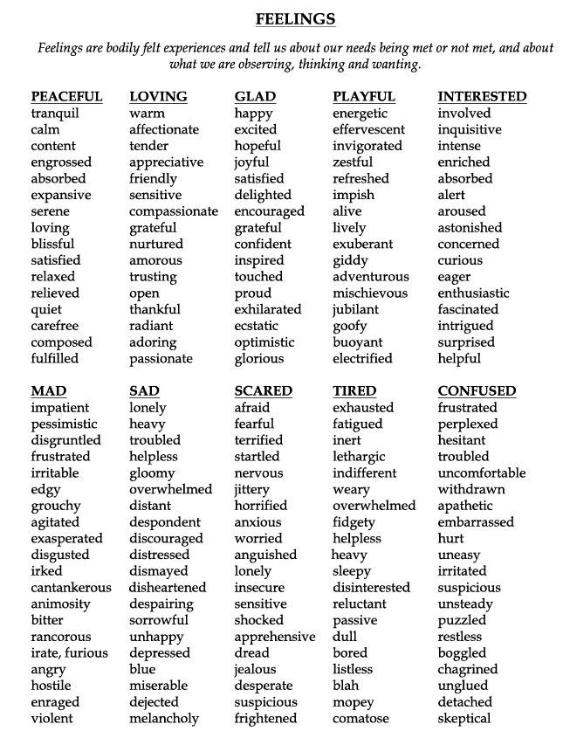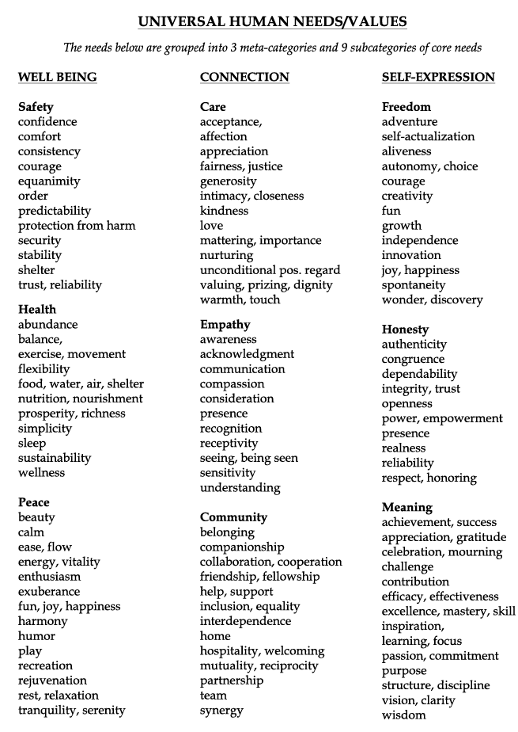
Handouts by John Kinyon, www.johnkinyon.com, www.mediateyourlife.com, (415) 710-2777

Self-Disclosure
In casual conversations, you might talk about yourself, your feelings, and your own life experiences to find and foster connections with others. In a counseling or therapy context, this is often referred to as self-disclosure. While self-disclosure can be a powerful tool to build rapport in a coaching setting, it is not required for a successful coaching relationship, and it can be harmful if practiced too often or inappropriately.
A good rule of thumb for self-disclosure is to avoid talking about yourself unless you can do so in a way that centers your peer’s needs. For example, if a student is struggling with impostor syndrome, it may be appropriate for a coach to share about their own experience overcoming impostor syndrome; similarly, if a peer is struggling in a course that their coach has successfully completed, they could share the strategies that worked for them, with an acknowledgment that the student may benefit more from a different approach.
A useful acronym is WAIT: Why Am I Talking? Check in with yourself to make sure you are listening to understand, not just to respond, and that you are centering your peer’s needs and experiences.

Icebreaker Questions & Activities
For many students, the word “icebreaker” may evoke memories of structured activities in a school or camp setting, such as “Two Truths and a Lie” or the “Name Game.” While these can be effective tools for Peer Coaches to help establish rapport in group settings, an icebreaker can also be a go-to question (or two) that a coach asks to start a conversation. These could be more general, such as “What is your favorite thing about WashU?” or more coaching-oriented, such as “What is something new you’ve learned about yourself this semester?”

How will you work to build rapport with students during your coaching sessions? How might your approach differ with a student who is shy and hesitant to talk about themselves, versus a student who is friendly and outgoing, but prone to tangents?

Describe your favorite icebreaker activities or questions. Even if they’re silly, they’re humanizing and effective!

Inclusive Facilitation & Bias Considerations
Inclusive facilitation is a set of practices which actively engage with the diversity of a group in ways that increase awareness, content knowledge, cognitive sophistication, and emphatic understanding of the complex ways individuals interact within systems and institutions. Research has shown that inclusive facilitation…
- Validates students’ decisions to make use of support programs and resources.
- Helps students accept critical feedback as valuable.
- Increases students’ sense of belonging, which is strongly correlated with academic success
(persistence, grades, and motivation).
- Encourages students to develop a growth mindset.
- May help reduce impostor syndrome.
The curb-cut effect is a great case study in inclusivity and universal design. See more here and here.
And remember, a student’s sense of belonging strongly correlates to academic success!

Peer Coaches are also encouraged to familiarize themselves with the concepts of negativity bias and stereotype threat and the ways they may affect students’ academic experience.
Negativity bias is a cognitive bias that results in adverse events having a more significant impact on
our psychological state than positive events. The negativity bias has a significant impact on our individual decision-making. Read more here.
Stereotype threat refers to the risk of confirming negative stereotypes about one’s racial, ethnic, gender,
or cultural group. This phenomenon can lead to heightened stress, anxiety, and cognitive overload, which
divert mental resources away from academic focus, performance, and relationship-building. Read more
here and here.
Below is a non-exhaustive list of strategies Peer Coaches can apply to facilitate more inclusive sessions:
- Avoid linking students’ performance with “natural” ability or “talent”
- Communicate your belief that all students can succeed
- Emphasize struggle and challenge as important parts of the learning process.
- Avoid generalizations that may not include all students (e.g., living in a house, having two parents,
going on vacation, watching football, etc.)
- Admit when you make a mistake and accept feedback from others.
- Present information and assess understanding in multiple ways.
- Actively self-question to challenge your own assumptions and biases.
- Help students manage feelings of stress and anxiety associated with the threat of fulfilling stereotypes about their identities.

Identity reflection activity: Take a minute to reflect on the ways in which you identify. Which categories from
the list below resonate with you? Which ones do you think of most often? Which ones are less visible?
- Place of birth/national origin  - Gender  - Sexual orientation  - Race/ethnicity  - Religious/spiritual affiliation | - Socio-economic status  - Disability  - First language  - Family background  - Education background

Did you learn anything new about yourself? How might your experiences, words, and assumptions influence
your Peer Coaching sessions?

Specific Support and Strategies
While the academic coaching models and philosophy outlined above can be applied in a variety of contexts,
a Peer Coach’s primary responsibility is to help their peers develop foundational academic skills. These skills
are listed below, along with relevant coaching strategies and supplemental resources.

Setting Goals
Goal setting is an essential skill for success in college, as goals can give students direction and help them find the motivation to learn and achieve. The Learning Center encourages Peer Coaches and students to set goals using the SMART framework. SMART goals are Specific, Measurable, Action-Oriented, Realistic, and Time-Bound. Making sure the goals you set for yourself have these 5 attributes will help you to focus your efforts and identify actionable steps to achieve them, which makes them more manageable, increases motivation, and ultimately improves your chances of a successful outcome.
Below are some suggestions and questions to consider while creating SMART goals.
Specific:
- What exactly will you accomplish?
- Do you need to break your goal down into smaller objectives to give it specificity?
- Consider the “W” questions: Who, What, Where, When, and Why?
Measurable:
- How will you know when you have reached the goal? How can you evaluate whether
you were successful?
- How will you measure your progress along the way?
Action-Oriented:
- What concrete steps must you take to achieve your goal? Is there a clear progression from
one step to the next, and does each bring you closer to success?
- Does your goal include active or passive language?
Realistic:
- Is achieving this goal realistic with effort and commitment? Are the steps to achieving this goal
relatively clear?
- Do you have the resources to achieve this goal? If so, what are they? If not, how will you get them?
- What are some potential obstacles and challenges to success, and how do you plan solve or account
for them?
Time-bound:
- When will you get this done?
- Does the completion date create a practical sense of urgency?
- Do the action items required to accomplish your goal have their own deadlines?

Here is an example of how the SMART framework can be used to improve a vague, non-specific goal:
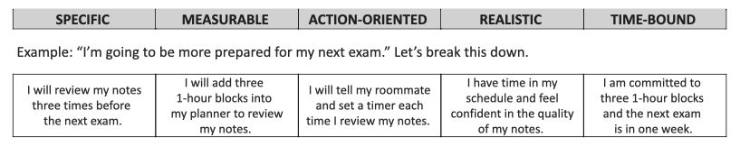
If a student finds that the SMART framework as stated here does not work for them, they may find it helpful
to experiment with other criteria; a list can be found here. Popular alternatives include:
- CLEAR: Collaborative; Limited; Emotional; Appreciable; Refinable, created by Adam Kreek
- GROW: Goal; Reality; Options; Will, developed by Sir John Whitmore
Try reframing one of your personal goals using the SMART framework.
Start by sharing your original goal, then use the table below to break it down:

SPECIFIC | MEASURABLE | ACTION-ORIENTED | REALISTIC | TIME-BOUND

Which of the five components of the SMART framework do you find most useful and why?

Time Management
The key to successful time management in college is to plan ahead. There is no perfect “one size fits all” strategy for staying organized and budgeting your time, so students may need to experiment a bit to find a system that works for them.
Peer Coaches are encouraged to use the “Spectrums of Time Management,” pictured below, as a resource
to help students to reflect on their current practices and explore new time management resources.

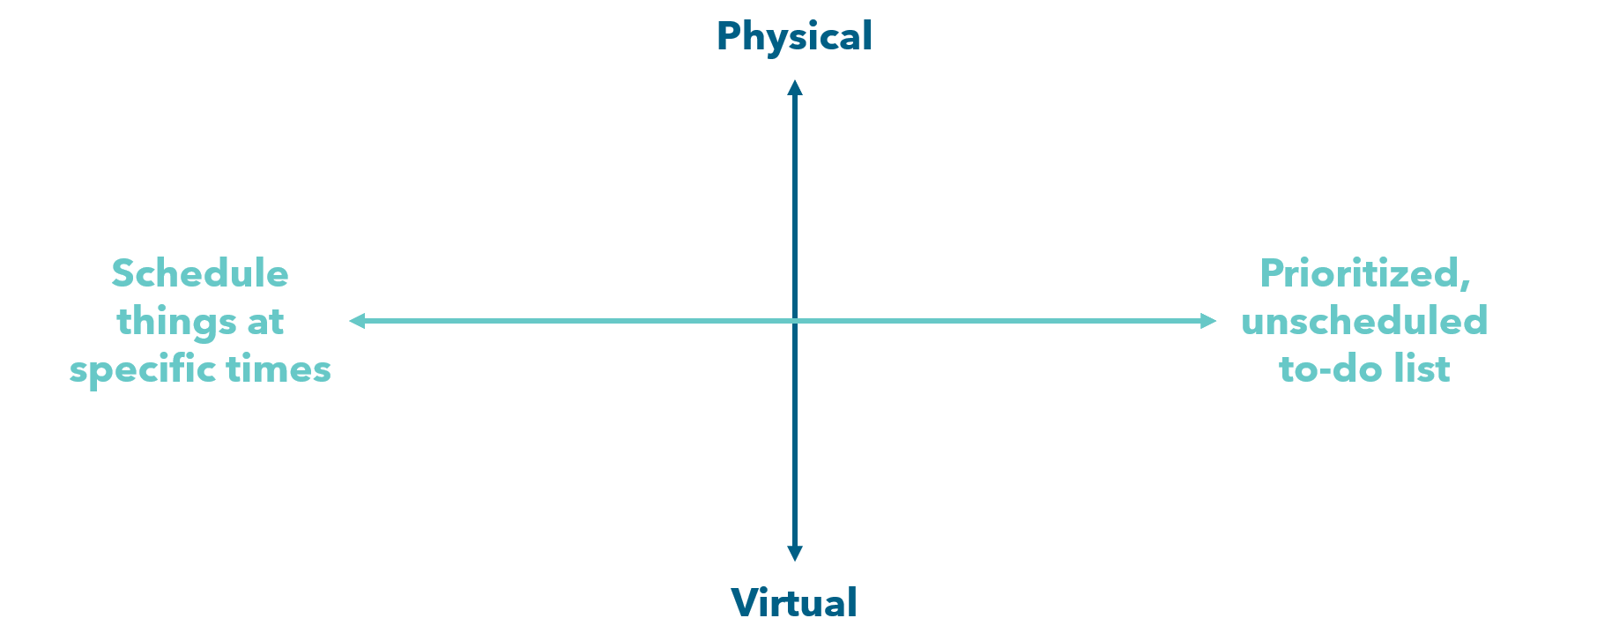
Outlook Calendar, Google Calendar,
Apple Calendar
Notion, Todoist, Trello, Workflowy, Nozbe,
My Life Organized, Asana,
Google Docs/Sheets
Passion Planner downloads
(Free PDF calendar &
planner layouts)
4-column template, bullet journal, unstructured planner

Here are some evidence-based strategies and question prompts to share during a coaching conversation
on this topic:
- Use a planner or calendar to stay organized.
  - What system do you currently use to manage your schedule? What aspects of this method
do you like or dislike?
  - What do you usually plan for in your schedule? Is it comprehensive enough to meet your needs outside of firm regular commitments? (e.g. office hours, study hours, mentoring sessions)
- Make planning a habit.
  - Can you tell me about how you maintain your planner/calendar?
  - How frequently do you update it?
  - What factors help you maintain a consistent and accurate scheduling system?
What factors make it harder?
  - How much flexibility do you give yourself when you create your schedule?
  - Does your method of scheduling bring you more peace or more stress?
- Engage in self-reflection to identify when you are most productive.
  - What aspects of your schedule reflect your habits and strengths? Are there any aspects
that work against them?
  - What conditions are most conducive to you meeting your schedule goals? (e.g. time of day, study environment, presence of music, presence of other people)
- Create to-do lists with set deadlines; consider using the template below.
  - What strategies do you typically use to prioritize tasks? Have these strategies been helpful?
To-Do Item | Time Needed | Deadline | Priority Level
 |  |  | 1 2 3 4

- Examine the role of urgency in your time management system.
  - How do you typically decide what tasks are most urgent? How accurate have these decisions been in the past?
  - How do you take care of yourself when you have an urgent task that may bring up feelings
of stress and anxiety?
  - Consider using the Eisenhower Matrix (also called an Urgent-Important Matrix) below to determine the best urgency-driven time management plan:
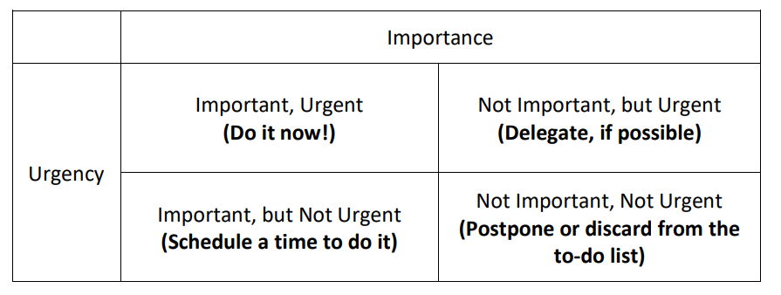
- Break large tasks into smaller, more manageable sub-tasks.
  - Consider using a hypothetical situation to prompt reflections on breaking up tasks:
    - Imagine you have another [test, paper, project, etc.] due in two weeks. Can you walk
me through a timeline of when you would prepare for this and how you might plan
to break up the tasks?
  - If the student already breaks up the tasks into sub-tasks, consider reflecting on the accuracy
of their time allocations for each sub-task:
    - Do your plans for working on specific parts of your [study plan, project, paper outline, etc.] tend to reflect the actual amount of time it takes you to complete these tasks?
    - How does this time differential affect your other classes and commitments (this includes personal necessities)?
    - What are some of the ways that you could adjust your plan to fit the reality of your needs for this larger task and the smaller sub-tasks you identified?
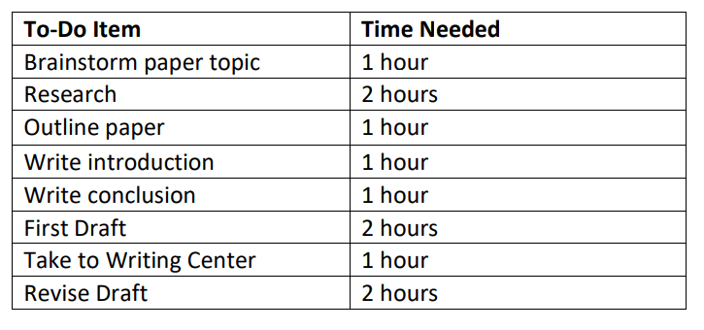
- Plan backwards. Identify a specific end goal (such as completing an assignment or taking an exam on a specific date) and work in reverse to build a timeline of deadlines for the sub-tasks you’ll need to complete to reach your goal in the desired timeframe. For more information about backwards planning, including a detailed example, check out the NC State Academic Success Center’s short video tutorial.
- Reward yourself for completing tasks on time.
  - Can you tell me about how you incorporate breaks into your study time? Does it typically feel like enough time/feel refreshing?
  - How do you reward yourself for completing your academic goals within the time period you planned for them?
  - How do you schedule time for things you like to do?
Students can learn more about time management on the Learning Center’s website:
Time Management & Productivity Strategies
Brainstorm 2-3 open-ended questions that you could ask a student to help them identify and articulate
their specific challenges with time management.

How would you support a student whose time management system is very different from the one you
personally use?

Memory and Time Management
It is useful to recall how our working memory can inform time management. The process of sifting, organizing and prioritizing new content is visualized below. Through active maintenance, we are always building a knowledge archive where short-term memory retrieves long-term stored information and thus encodes content.
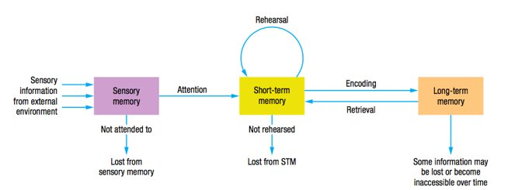
Cognitive load is the amount of information our working/short-term memory can hold at a time; most can hold 3-5/up to 7 chunks at a time. For example, see the Learning Center phone number below, before and after chunking. Chunking applies to both content and planning.
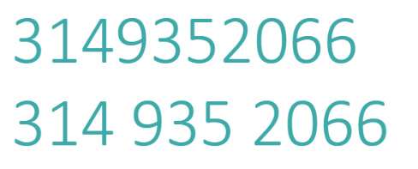
And don’t forget Ebbinghaus’ Forgetting Curve! The more we interact with content, the more it encodes into our long-term memory. Regular interactions with content will flatten the curve! See our semester planner template for a big picture view in addition to the weekly plotter.

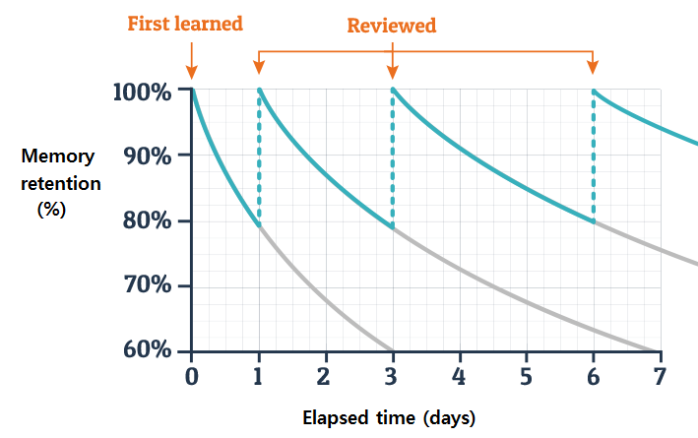

Canvas Calendar Feed
Students who prefer to keep track of upcoming assignments and exam dates using a digital calendar may find it helpful to sync their Canvas calendar with their Google, Outlook, or Apple calendar. This will ensure that due dates, events, and reminders from Canvas show up and are automatically updated on their calendar of choice.
Below is a step-by-step guide to help Peer Coaches guide students in setting up their Canvas Calendar Feed:
- Open your Canvas calendar.
  - Log into Canvas on a laptop or desktop computer.
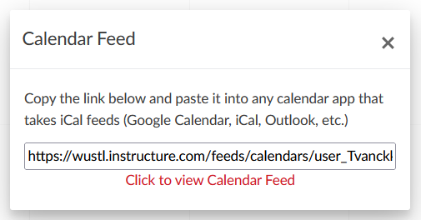
  - Click on Calendar in your left sidebar to open your Canvas calendar.
- Find the Calendar Feed link.
  - On the bottom right-hand side of the calendar page, find the text that says Calendar Feed.
  - Click on it, then copy the long URL that appears. This is your personal Canvas calendar feed link.
- Add the feed to your personal calendar. Instructions differ slightly for different calendar systems:
Google Calendar | Outlook Calendar | Apple Calendar
- Open Google Calendar.  - From the left sidebar menu, click the “+” next to “Other Calendars.”  - Select from URL.  - Paste the Canvas calendar feed link you copied.  - Click Add Calendar.  Your Canvas events will now appear under other Other Calendars in Google Calendar. | - Open your Outlook calendar.  - From the left sidebar, click Add Calendar.  - Select Subscribe from Web.  - Paste the Canvas calendar feed link you copied.  - Click Import. | - Open Apple Calendar on your laptop or desktop computer.  - Open the File drop-down menu from the top-left corner of the screen.  - Click on New Calendar Subscription.  - Paste the Canvas calendar feed link you copied.  - Click Subscribe.  Instructions to subscribe to the Canvas calendar feed on an iOS device can be found on Instructure’s website.

It should be noted that this feed may take a few hours to update, and it will only sync assignments and other course activities that instructors have posted to the “Assignments,” “Discussions,” or “Quizzes” sections of a Canvas course with due dates. Some instructors may not to use these features to share assignment details, or may do so inconsistently, either due to personal preference or their level of comfort with the Canvas platform. For this reason, Peer Coaches should encourage students to periodically check Canvas for announcements and updates, even if they have their Canvas Calendar Feed synced to their personal calendar.

Study Strategies
One of the biggest challenges many students face in navigating the transition from high school to college is learning how to study. The cognitive psychological scientists behind The Learning Scientists share six evidence-based study strategies that students can apply to enhance their own learning. The printable graphic below
is also available through the Learning Center’s academic skills resource library.
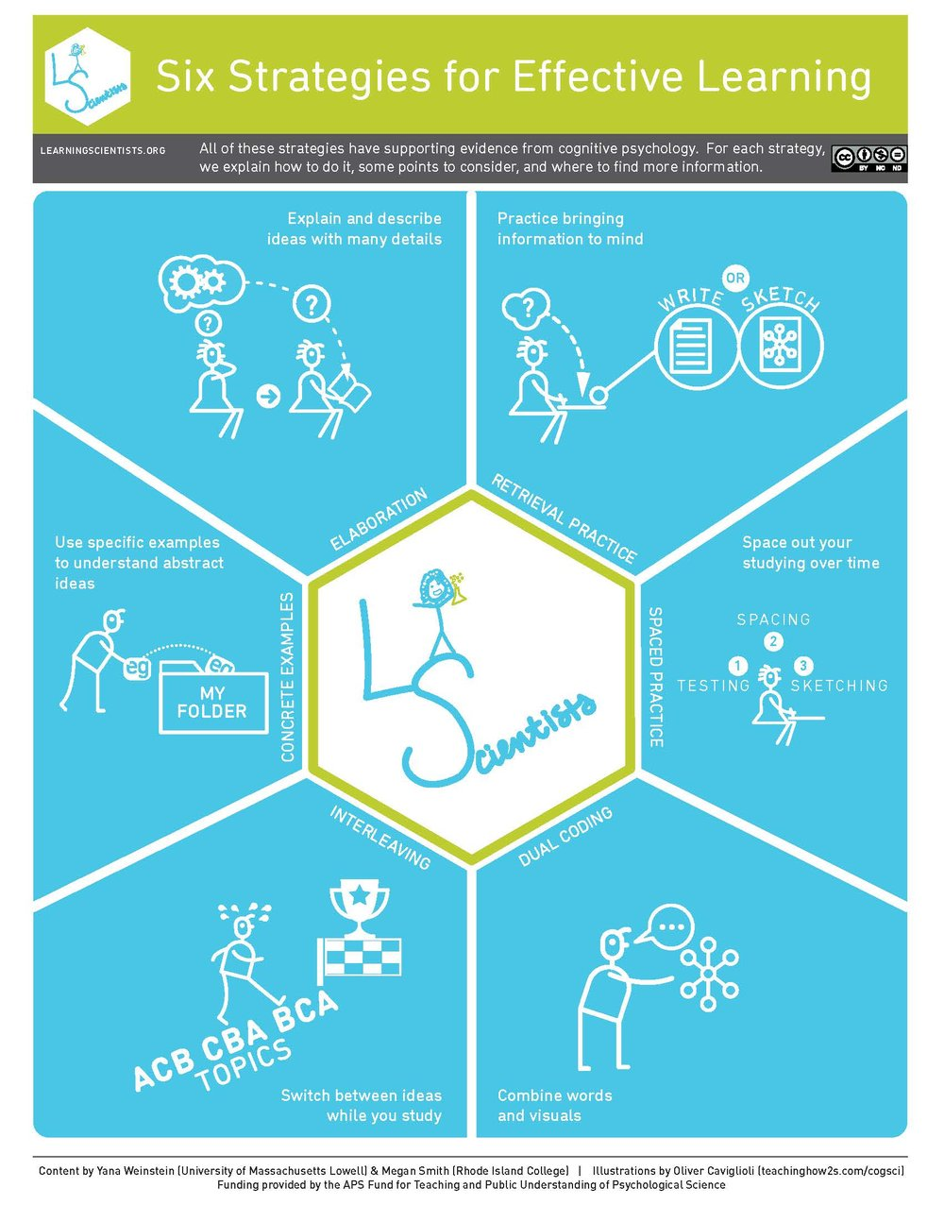
More information, including detailed, downloadable posters about each of the six strategies, can be found
on the Learning Scientists website.
In your own words, describe each of the six strategies and a time that you have used (or could have used) them
in your own academic life.
Concrete Examples:

Dual Coding:

Elaboration:

Interleaving:

Retrieval Practice:

Spaced Practice:

Note Taking
Taking notes, reviewing them, and synthesizing information positively affects your learning process. Research has shown that taking notes actively can make you more likely to remember information and can help you perform better on exams. Note-taking and synthesizing notes will help you gather notes from various sources (lectures, texts, etc.). It can help you keep course materials more organized in an easy to comprehend manner that will make exam preparation easier.
Below are some key note-taking strategies that Peer Coaches can share with students:
- Don’t try to write or type what the professor is saying word-for-word. Instead, paraphrase.
  - If you are too focused on trying to transcribe the lecture, you will miss important information,
as you will not be synthesizing the information as you go.
  - Instead of transcribing, try to listen for verbal cues that indicate how information should
be organized, or which information is important. Your instructor may repeat something,
use a different tone, or explicitly stress a concept’s importance.

- If possible, try handwriting your notes instead of typing them.
  - This will force you to synthesize and paraphrase information as you go, since most people cannot write as quickly as they can type.
  - Additionally, research suggests that engaging multiple senses helps the brain retain information more effectively.

- Write notes you will use. There is no one-size-fits-all strategy for taking notes; different formats will work better for different people, or even different classes. You may need to experiment with different formats at the beginning of each semester, and that’s okay!
  - Common note-taking formats include outline notes, Cornell notes, and concept maps
(see below). These examples are not exhaustive, but they may be a helpful starting point.
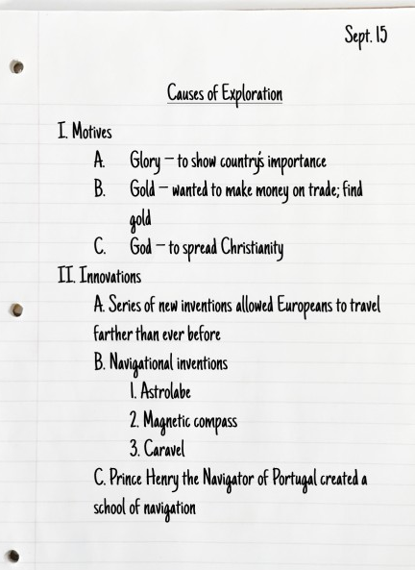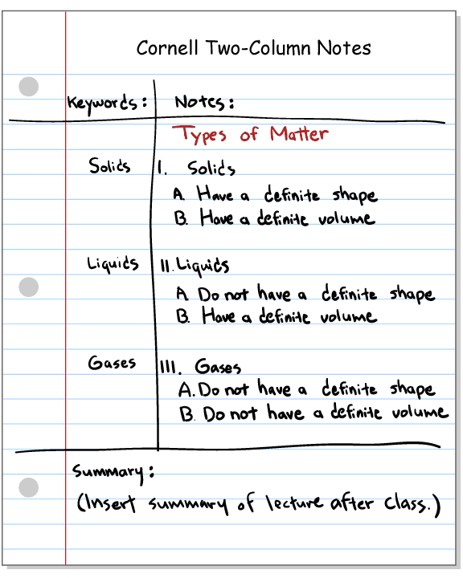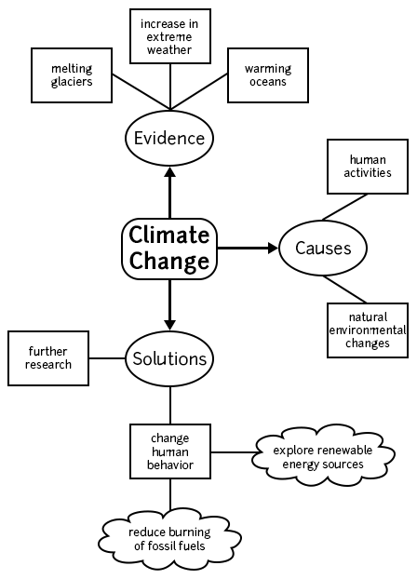
- Preview the lecture agenda or reading material before you start taking notes.
  - This can help you determine the most effective way to structure your notes.
  - You may also be able to identify potentially challenging concepts in advance, which will prompt you to pay closer attention when reading the material or discussing it in class.

- Mark topics you don’t understand or didn’t finish writing down so you can return to them later.

- Expand and review your notes after class. Notes can only help you learn if you remember to look
at them after you write them!
  - Clarify or expand on any topics you marked during class.
  - Swap notes with a classmate to gain another perspective.
  - Find or create concrete examples of abstract or theoretical concepts.
  - Incorporate dual coding by finding ways to represent information visually in addition to text. Depending on the subject, this could involve drawing and labeling a diagram or creating a concept map, among other approaches.
  - Create a one-page “cheat sheet” for an exam. Even if you are not permitted to use this resource during the actual exam, it’s a very useful exercise in reviewing and synthesizing information.
Students can learn more about taking notes on the Learning Center’s website:
Note Taking Strategies

What questions would you ask students (or encourage them to ask themselves) to determine which note-taking style would be most useful for a particular course?

How would you support a student who has trouble processing information during class and feels that their instructor is talking too fast for them to write anything down?

Reading
College reading is much more demanding and challenging than what most students encounter in high school. Students may feel unprepared for the amount and difficulty level of the readings, and the strategies that allowed them to succeed in high school may no longer work.
Increasing one’s comprehension and retention requires a deeper level of engagement and interaction with texts. Students can trick their brains into doing this by implementing interactive reading strategies.
Peer Coaches may find it helpful to ask students the following questions to prompt reflection on reading strategies:
- Imagine you have a long and dense text to read for a difficult class. Can you walk me through how you would approach reading it? What do you do first?
  - Do you typically use highlighting or underlining? Do you re-read the material? Do you rewrite sections of the text? Do you gloss over pages?
- What does “doing a reading” mean to you?
- What aspects of your current strategy do you feel serve you most?
- Which ones serve you least?
- How do you decide how much time to spend on a reading?
- How does the way you read change depending on whether it’s for a classroom discussion, an exam,
or a paper?
- When and where do you usually read? Have you noticed any particular settings that are more
conducive to effective reading?
Below are some evidence-based active reading strategies for close reading and related conversation prompts that coaches may share with students.
Pre-Reading:
- Questions for students to ask themselves before reading:
  - What will you be expected to do with the information that you gather from your reading?
  - What class or discipline is this for?
  - Is this for an exam, class discussion, or essay?
  - What are some things you want to learn from the text, and what questions do you have that you hope to be able to answer while reading or after reading it?
- Draw on prior knowledge; questions to help students make connections:
  - How does the topic of your reading relate to others you’ve read about for class?
  - How does it relate to what your instructor has talked about during lecture?
  - Why do you think the instructor assigned this text?
  - Do you have any knowledge or experience from outside the course that relates to this reading?

Reading:
- Intentional skimming:
  - When might skimming be more useful than reading every word?
  - What parts of a reading do you usually look at first?
  - How do you decide what is important enough to slow down for?
  - How could skimming help you prepare for class, research, or writing?
- Taking notes while reading:
  - What do you usually write down when you take notes from a reading?
  - How do you decide what is worth putting in your notes?
  - Are your notes mostly copied from the text, or mostly in your own words?
  - What would help you make your notes shorter but more useful?
  - How do you want to use your notes late: Studying, writing a paper, class discussion…?
  - What note-taking format would best fit the kind of reading you are doing?
- Annotating or highlighting:
  - What do you usually highlight or mark when you read?
  - Do your annotations help you understand the text, or do they mostly help you feel like you are “doing something?”
  - What kinds of comments or questions could you write in the margins?
  - How could you use annotations to summarize instead of re-reading?
- Reflection and strategy building:
  - Which strategy feels most realistic for your current reading load?
  - What is one reading assignment where you could try this strategy?
  - What could you do before, during, and after reading to make the process easier?
  - What is one small change you want to try the next time you read?
Post-Reading:
- Checking for understanding:
  - After finishing a reading, how do you usually know if you understood it?
  - What tends to get in the way of remembering what you read?
- Recall and review:
  - If you closed the text right now, what do you think you would remember?
  - How comfortable do you feel trying to recall information without looking back?
  - What might be helpful about writing down what you remember from memory?
  - Would you prefer outlining, free writing, or talking it out. Why?
  - How might testing your memory change how you read in the first place?

Students can learn more about reading strategies on the Learning Center’s website:
Strategies for College Reading

Growth Mindset
A growth mindset is the belief that intelligence is not an innate, unchanging quality, and that one can master any skill or concept with enough time, effort, and practice. Much of the current research on intelligence supports this theory. The opposite of a growth mindset is a fixed mindset, which occurs when one believes
that they have been born with all the intelligence or aptitude they will ever possess, and they are simply not equipped to succeed in some domains.
A student’s mindset and beliefs about intelligence can affect their motivation and approach to work, which can in turn affect their academic performance. The graphic below illustrates some key differences between students with a fixed vs. growth mindset:

The following are common signs that a student has a fixed mindset about the class or task before them:
- “I’m not an [X] person”  - Gives up easily  - Highly self-critical  - Ignores useful negative feedback  - Sees effort as pointless, or a sign  of unintelligence | - Views the success of others  as a threat  - Strongly resists any sort of challenge  - Avoids failure at all costs, while striving for success  - Criticizes or judges others
When supporting students who are stuck in a fixed mindset, Peer Coaches are encouraged to offer strategy feedback, as opposed to comfort feedback. Comfort feedback can make a student feel heard (e.g., “Yeah, this is a tough class, and I know a lot of students struggle with the second exam”), but may reinforce a fixed mindset unless accompanied by strategy feedback. Keeping with the example in the previous sentence, appropriate strategy feedback could include specific study strategies, or a suggestion that the student reflect on their exam performance to determine how to refine their approach to the next one.
Other potentially useful strategies to foster a growth mindset include:
- Emphasizing the student’s strengths – everyone has them! At the very least, the student reached out
to a Peer Coach for support, which can be a big step that deserves recognition.
- Celebrate mistakes as learning opportunities.
- Encourage students to develop learning goals in addition to or instead of performance goals. Performance goals are often focused on grades (e.g., “I need to earn at least an 88.6% on my final exam to pass the course”), whereas learning goals focus on the skills or information a student needs to master to succeed (e.g., “I will complete practice problems until I can apply this concept without checking
my notes”).
- Share their own personal examples of academic challenges or a struggle with a fixed mindset,
where helpful and appropriate.
- Share their own academic goals and encourage students to set their own goals.
Students who are interested in developing a growth mindset may find it helpful to learn about the science
of learning and neuroplasticity. This short video by Sentis is a great starting point!

What signs of a fixed mindset have you noticed in yourself or others?

Think back to a time you were stuck in a fixed mindset (not necessarily in an academic setting). What experiences or advice helped you move towards a growth mindset?

Managing Procrastination
Procrastination is the act of choosing to do something that is less of a priority in order to avoid tasks that are more challenging or unpleasant. It is often a coping mechanism that provides temporary relief for longer term problems. Procrastination is much more than a time management problem. The first step to overcoming procrastination is to understand reasons for delaying the tasks. Below are some concrete strategies and question prompts Peer Coaches can use to help students understand and manage procrastination.
- Developing Awareness
  - What kind of tasks do you typically procrastinate on?
  - What are some of the reasons why you might procrastinate on these tasks?
  - What feelings come up for you when you notice that you have procrastinated?
- Brainstorm Strategies
  - Have you ever tried any strategies to reduce procrastination? How did they go for you?
Reasons for Procrastination | Brainstorming Questions
I don’t feel  like doing it | - What are your long-term goals?  - How does completing this task or course relate to achieving your long-term goals?  - How would this task help you grow in your skills?  - What are the consequences of not doing this task?  - What are some strategies you have used in the past to find motivation to complete  a task you did not want to do?
I don’t know how | - Who can you reach out to for support?  - How have you approached this task? Are there any ways to break it down?  - What aspects of this task seem the hardest? What aspects seem the most manageable?
I don’t know  the prerequisite information /  it is too hard | - What resources are available to you through the course?  - Who can you reach out to for support?  - What are some strategies you have used in the past to overcome challenging tasks in  the past? How do you think they helped? Can they be applied to your current situation?
What if I don’t  do it well? | - Can you tell me about a time where you thought you were not going to succeed, but did? What strategies did you use? Can you apply them to your current situation?  - What thoughts or actions made it harder to do well? How can you use this insight to promote your success?
It is boring | - How does this task contribute to you achieving your long-term goals?  - How have you overcome boredom in order to do other important tasks (e.g. chores)?  How did you eliminate distractions or create motivation to do these tasks?  - What do you usually do when you try to accomplish this task? Which practices are helping? Which are harming?
I waited too long to do it | - What do you think is the reason that you waited longer than you would have liked  to start this task?  - Did you create a plan beforehand? What worked? What didn’t? If not, are you interested  in developing a plan for future projects?

- Create goal or action plan; consider using the template below:
Task that you procrastinate on often | Why do you procrastinate? | What do you usually do instead? | What is your strategy to overcome procrastination?
- Reflective questions to consider while revising the action plan:
  - Does this plan seem realistic given your timeline, schedule, and habits?
  - What spaces have you found to be most conducive to effective studying?
  - When will you know if you need to reach out for help?
  - Will a rewards/punishment system work? What “if-then” rewards motivate you?
- Predict and Manage Challenges
  - What are some of the activities you do when you are procrastinating on a particular task?
  - What are some strategies that you could implement to minimize access to these other activities when you need to work on a task that you would normally procrastinate on?
  - After going through this action plan, how prepared do you feel to challenge patterns of procrastination? What are the biggest challenges you anticipate? The biggest strengths?
- Find or Create Accountability Structures
  - How have you tried to hold yourself accountable to your goals in the past?
  - How can you externalize or track your progress towards your goals?
  - Who in your support network might be willing to hold you accountable to deadlines or
“body double” while you work?
- Practice Self-Compassion
  - What are some ways that you can practice self-compassion as you start this journey of working on procrastination habits?
Students can learn more about managing procrastination on the Learning Center’s website:
How to Reduce Procrastination
What other strategies would you recommend to a student who is struggling with procrastination? You can draw from your own experience, as long as you do so in a way that centers the student’s perspective and needs.

Reflection
Reflection is an important step in the metacognition cycle that many students skip, but by viewing exams, papers, and other assessments as part of an ongoing learning experience instead of an isolated event, students can learn from their mistakes, build on their strengths, and set themselves up for long-term success. By engaging in active, intentional reflection, students can…
- Process the experience mentally and emotionally, then move on.
- Anticipate and prepare for future challenges.
- Re-evaluate and improve their plans and goals.
- Transfer and adapt learning to new contexts and tasks.
- Develop independence as learners.
Peer Coaches should encourage students to ask reflective questions throughout their learning process. Below
is a non-exhaustive list of examples, courtesy of UNC Chapel Hill’s Learning Center.

What are some other examples of self-reflective questions that students might ask themselves when learning or reviewing information?

Gibbs’ Reflective Cycle is a theoretical model, developed in 1988 by Professor Graham Gibbs, that provides a structured framework for experiential learning through a structured six-stage process of reflection. This cyclical model, as opposed to a linear one, emphasizes the importance of continuously revisiting experiences, analyzing them from different angles, and using the insights gained to inform future actions and improve decision-making.
Try using the following graphic during a peer coaching session!
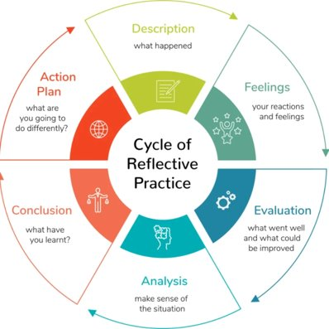
Image courtesy of medium.com
Students can learn more about reflection and access a huge bank of exam self-reflection questions
on the Learning Center’s website: Post-Exam Reflection Worksheet
Students can be reluctant to reflect on past exams or assignments due to feelings of shame about a less-than-ideal grade or performance. What would you say to a student in this situation?

Addressing Test Anxiety
Test anxiety can be defined as a situation-specific anxiety experienced in evaluative situations. This includes
the worry, nervousness, and/or bodily responses (i.e., sweating, trembling, increased heart rate) you feel in response to a situation where you’re getting evaluated (written or oral exams, presentations, driving tests etc.).
Although low levels of nervousness or stress before a test are fairly common and may even be helpful, it is thought that test anxiety lowers test performance by enabling students to shift attention from the evaluative situation to themselves. In addition, it is suggested that individuals exhibiting test anxiety struggle with
re-allocating mental resources to solve various tasks, impeding test performance.
As a Peer Coach, you are encouraged to ask open-ended questions to explore to help students plan ahead
to reduce test anxiety:
- Ask about study habits:
  - How have you been studying for your exams?
  - How does your study environment replicate the testing environment? (e.g. under time pressure, with no notes or books, in a well-lit, quiet, relatively distraction-free space)
  - What strategies have you tried in the past that have made you feel more confident before
an exam?
  - What study strategies have been least helpful for you?
- Ask about connections to resources:
  - Who have you spoken to about your test anxiety? Were they supportive?
  - What/who are some potential resources you could reach out to in order to see if you are studying effectively for the exam? (e.g. TA/AI)
  - Affirm that it can be difficult to reach out for help, especially from a professor, but that it
does not hurt to ask!
- Ask about non-academic exam preparation:
  - What do you do to take care of your body and mind in the days leading up to the test? (e.g. sleep, hydration, nutrition, caffeine intake)
  - How do you incorporate breaks from studying to relax, exercise, meditate, or engage in another form of self-care?
  - Are there any other ways you wish you could prepare physically, spiritually, or emotionally before an exam that you have not tried yet?
- Ask about feelings related to the exam:
  - What aspect of the test brings you the most anxiety?
  - Can you think of anything that would help make this exam feel less threatening?
  - What would success on this exam look like for you?
  - How will you feel when the test is over, and you have done well? What will that look like?
- Ask about mindfulness and breathing strategies:
  - What mindfulness and breathing exercises have you tried, and do you find them helpful?
  - Would you like to learn more about some techniques that you could use before, during,
or after an exam?
- Ask about preparation for the day of the exam:
  - What are some steps you could take to feel more prepared to go take the exam?
(e.g. arriving early, gathering materials ahead of time)

Students can learn more about managing test anxiety on the Learning Center’s website:
Managing Test Anxiety

What other strategies would you recommend to help a student reduce their test anxiety?

How would you support a student whose test anxiety is having a significant negative effect on their well-being,
or seems to be affecting other domains of their life?

Strategic Use of Generative AI
All WashU students should complete the AI Literacy module. This is the first step in understanding how the university is thinking about AI best practices. WashU also uses the AI Assessment Scale to help guide faculty. Beyond that, there are many questions each student must consider individually. Students will be confronted by differing policies per instructor and sometimes per assignment within the same course. It could be useful to follow the line of questioning below during appointments.
- Does the professor allow AI? See syllabus. Write down anything that is unclear and ask.
- List the reasons you would use AI for a specific course or assignment.
- Will AI interfere with your learning, or will it add to it? Do you feel you are giving something up?
- Are there bigger concerns about AI for you personally/ethically?

Let’s practice! Think of your own major and a specific course. Then think of an academic context within which you would use AI. Walk through the points above. Discuss the pros and cons.

Or assess these scenarios provided by the CTL:
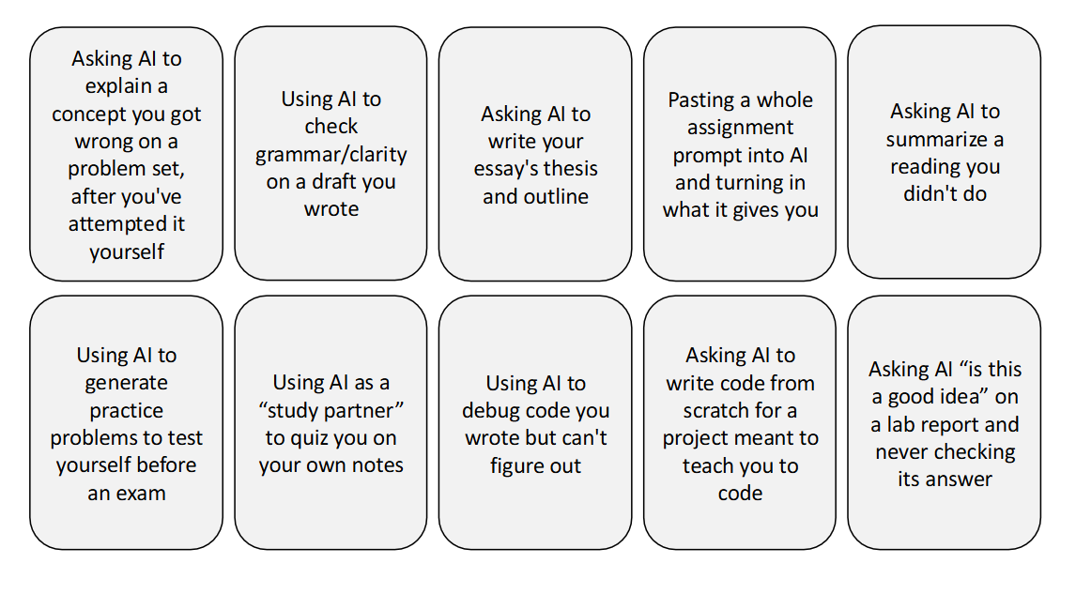
Don’t commit an AI violation by using AI! Familiarize yourself with WashU’s Academic Integrity Policy.

Supporting Neurodivergent Students
Neurodivergence is a brain-based difference in how we think, learn, socialize, and process our sensory environment. It’s not a measure of intelligence or ability, and no one needs to be fixed. Common hallmarks are masking, comorbidities with other neurotypes or mental health conditions, and executive functioning challenges.
As a peer coach, your role is not to diagnose, and you should refer to Disability Resources or to one of your supervisors if a student is seeking an assessment. Thoughtful language is key, especially as this disability is often invisible. Only a group can be neurodiverse, and an individual neurodivergent. Neurodivergent students have strengths like anyone else, which is always good to build upon during your appointments. You may also ask a student who identifies as neurodivergent, what that means to them, i.e. “tell me more.”
The skills below are interconnected, and both neurotypical and neurodivergent students are refining these at any given time. Consider how one skill supports or hinders another for yourself in a given context. Describe your example and then turn it into an open-ended question that would reveal the connections.

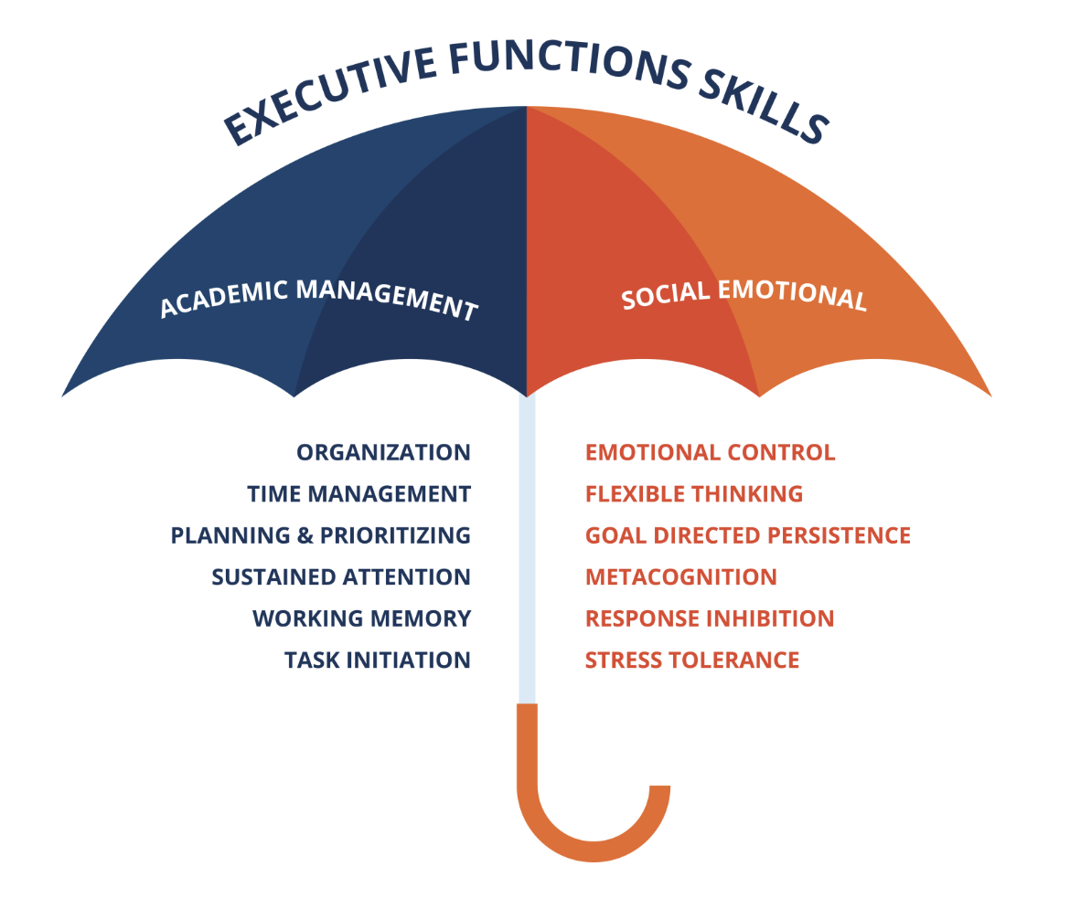

Academic Support Ecosystem: Resources & Referrals
Below is a graphic that Learning Center staff often share with current and prospective students to illustrate the diversity and quantity of academic support that is available both within and outside of our office. Peer Coaches are encouraged to familiarize themselves with the Academic Support Ecosystem and are welcome to share this graphic with peers.
Academic Support Ecosystem
The Learning Center

What would you emphasize when sharing the Academic Support Ecosystem with a peer? Are there any resources you would add?

Other Learning Center Resources
Peer Coaches are expected to be familiar with and able to make referrals to other Learning Center
resources, including:
- Peer-Led Team Learning (PLTL): Peer Led Team Learning is a model of collaborative learning that supplements General Chemistry, Calculus, and Physics courses at WashU. In PLTL, 8-10 students work together on a packet designed to develop course-relevant problem-solving skills in a study group facilitated by a Peer Leader. Students must sign up for PLTL courses during the first week of classes.
- Residential Peer Mentoring (RPM): Drop-in support for Calculus and General Chemistry courses; sessions take place in residence halls on the South 40. Students can attend as many sessions as desired, as there is no attendance policy. This type of mentoring is most helpful when students have questions about specific concepts or problems.
- Drop-in Academic Mentoring: Mentoring sessions (similar to RPM hours) for a variety of large lecture courses besides Calculus and Chemistry; sessions are held in various locations, typically on the
Danforth campus.
- Matched Academic Mentoring (MAM): Small group support for eligible students who are struggling in foundational courses due to gaps in their foundational knowledge, learning disabilities, or other challenges. Students request support by filling out a form on the Learning Center’s website; staff typically follow up within 10 business days.
- Study Group Finder: Students can fill out a form to either request to join a study group for a specific course or pre-professional test prep, or let the Learning Center know about an existing group that is open to adding new members. If two or more students express interest in forming a study group for the same course, the Learning Center will connect them via email.

The Center for Teaching and Learning
The Learning Center is one of three divisions that make up the Center for Teaching and Learning. While the other two divisions, Educational Development and Classroom Services, primarily support teaching faculty, postdoctoral scholars, and graduate students, they also offer support and resources to support the Learning Center’s staff and mission. These include, but are not limited to:
- Events and workshops on a variety of topics, some of which may be open to undergraduate students.
- Tutorials, workshops, and updates regarding educational technology tools, including AI tools and resources like Read&Write, an assistive technology that supports students in reading, writing,
and studying.
- A detailed, searchable classroom directory that can help students learn more about campus spaces
or find a suitable location for an extracurricular event.
- Presentation and professional development opportunities for Peer Coaches and other Learning Center employees, who are often invited to participate in panels, focus groups, and other events that address students’ needs and experiences.

Campus Resource Directory
During meetings, Peer Coaches may learn that students need support from campus resources outside the Learning Center. Coaches may also find it helpful or necessary to make use of these resources to support their own academic success and well-being.
Campus Resource | Resources / Programs / Services Offered | Contact Information & Location
Disability Resources | - Housing accommodations  Academic/testing accommodations  - Note-taking  - Reduced course load | Website: disability.washu.edu  Email: disabilityresources@wustl.edu  Phone: (314) 935-5970  Hours & Location:  Monday - Friday, 8:30 AM - 5:00 PM  South 40, Gregg House, Lower Level  Appointment recommended
Writing Center | - Writing help appointments  - Speaking studio  - Personal statement assistance  - Workshops  - Thesis writing support | Website: writingcenter.wustl.edu  Email: writing@wustl.edu  Phone: (314) 935-4981  Hours & Location:  Monday - Friday, 9:00 AM - 4:00 PM  Mallinckrodt Center, Lower Level, Suite 130
Relationship and Sexual Violence Prevention (RSVP) Center | - Housing, academic, and protective order accommodations after sexual assault  - Implementation of a no-contact order  - Medical and counseling services | Website: rsvpcenter.washu.edu  Email: rsvpcenter@wustl.edu  Phone: (314) 935-3445  Hours & Location:  Monday - Friday, 8:30 AM - 4:30 PM  Seigle Hall, Suite 435
Center for Diversity and Inclusion / Bias Reporting | - Diversity and inclusion self-study guides  - Bias report and support system | Website: cdi.washu.edu  Email: diversityandinclusion@wustl.edu  Phone: (314) 935-7535  Hours & Location:  Monday - Friday, 9:00 AM - 5:00 PM  Danforth University Center (DUC), Suite 150
WashU Cares | - Case management for struggling students  - Coordinate on- and off-campus resources  - Report student in need of support | Website: caresteam.washu.edu  File a Care Report online  Email: caresteam@wustl.edu  Phone: (314) 935-3566  Hours & Location:  Monday - Friday, 8:30 AM – 5:00 PM  Danforth University Center (DUC), Suite 213-216  Enter through Suite 200 – The Office of the Vice Chancellor for Student Affairs
Student Health Center | - Medical care  - Pharmacy  - Psychiatry | Website: studenthealthcenter.washu.edu  Email (non-emergency): SHCInfo@wustl.edu  Phone: (314) 935-6666  - Option 0: General Office/Information  - Option 1: Medical Appointments  - Option 2: Counseling & Psychiatry  Hours & Location:  Mon, Tues, Thurs, Fri: 8:00 AM - 5:00 PM  Wed: 10:00 AM - 5:00 PM  South 40, Dardick House, Lower Level  (Corner of Shepley Drive and Big Bend Blvd)
Center for Counseling and Psychological Services | - Mental health counseling  - Mental health emergency and crisis response  - Group therapy and skill-building | Website: counseling.washu.edu  Email: CCPScoordinator@wustl.edu  (314) 935-6695  Hours & Locations:  Mon, Tues, Thurs, Fri: 8:00 AM - 5:00 PM  Wed: 10:00 AM - 5:00 PM  South 40, Dardick House, Lower Level (primary)  Seigle Hall, 4th Floor (satellite location)
Center for Career Engagement | - Career coaching and planning  - Assessments and skills training  - Access to job opportunities and resources through Handshake platform | Website: careers.washu.edu  Email: careers@wustl.edu  (314) 935-5930  Hours & Location:  Monday - Friday, 9:00 AM - 5:00 PM  Danforth University Center (DUC), Suite 110

