What is the Role of AI in Your Classes?
Resource from the Washington University in St Louis Center for Teaching and Learning

Summary
The fact is that artificial intelligence (AI) tools will play a role in your classes. Let’s think about what role YOU, the instructor, will play in setting expectations around AI usage and facilitating student learning about and with AI.

What to know about AI
AI has been around for years in education, with the most notable being the Intelligent Tutoring Systems that started in 1970 (Shute & Psotka, 1994) and expanding to writing assistants, admissions chatbots, code writing, grading assistants, and more. Now, AI is embedded in many tools we commonly use on our campus, including those supported by WashU (Microsoft Word, Gmail, Padlet, Gradescope, etc.).
Most of us will use these tools without knowing it, and many of us will deliberately seek out these tools to help complete a task, solve a problem, begin brainstorming, reduce administrative work, get help, and more. Hence, using AI is not only inevitable, but valued in most aspects of life. You can learn more at Inside Higher Ed Emerging Technology and AI report (June 2023). One figure from the report is shown below, highlighting how AI will be important in the workforce and important in learning materials.
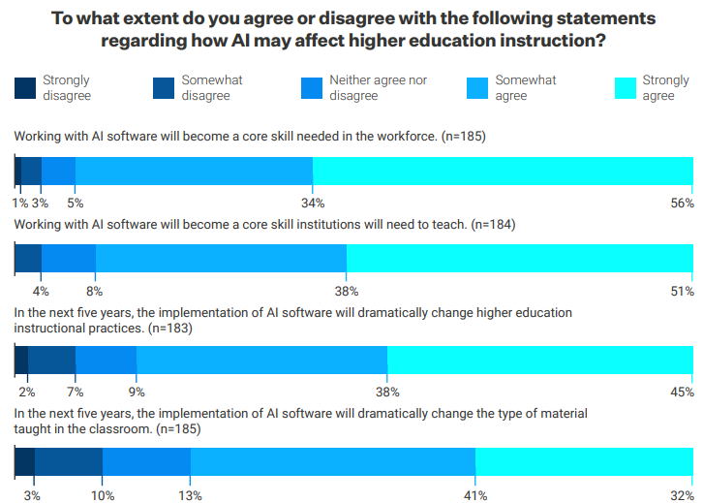

What you can do about AI in your class

Learn
  - Gain a general understanding of the affordances and limitations of the common AI tools.
    - Katie Metzler and ChatGPT, “How ChatGPT Could Transform Higher Education”
    - Prof. Ian Bogost’s article in The Atlantic, “ChatGPT Is Dumber Than You Think.”
    - OpenAI guidance for educators, creators of ChatGPT
    - Practical AI for Teachers and Students (YouTube playlist), Wharton School
      - Especially helpful is Video 3: Prompting AI
    - Canvas course built by students from University of Sydney
    - Additional Readings (caution: can lead you down a deep rabbit hole!)
      - Bryan Alexander: https://bryanalexander.org/future-of-education/resources-for-exploring-chatgpt-and-higher-education/
      - Heather Brown: https://padlet.com/DrHeatherBrown/resources-on-chatgpt-ai-and-education-itonvxbr22rpayy3
  - Identify how AI will be used by your students in academic and professional contexts
    - Learn about current and future usage in your discipline from political campaigns writing emails to a changing landscape of software development. Students may even be recruited by companies that provide ChatGPT Plus as a work perk.
    - Reflect on where it could help students with everyday tasks from answering basic questions to tutoring/mentoring students, especially for students who are non-native English speakers or need accommodations. Consider how students may use it for learning and contribute to a more inclusive learning environment.
  - Try the AI tools yourself by putting in the instructions for your assignments or common prompts students may input. Some common options are: ChatGPT (https://chat.openai.com/), Microsoft Bing (https://www.bing.com/?/ai), Claude.ai (https://claude.ai/chats)
    - Try out AI assistants designed for students, such as Grammarly (https://www.grammarly.com/), Quillbot (paraphrasing; https://quillbot.com/), Khanmigo (https://www.khanacademy.org/khan-labs#khanmigo), or for research: Elicit (https://elicit.org/) or Consensus (https://consensus.app/)
      - More AI tools students may use (a crowdsourced Padlet)

Plan
  - Reflect on the potential role of AI in your discipline and the teaching of your discipline.
    - Revisit your learning objectives for the class and consider modifying them to include goals that focus on learning with or about AI.
  - Outline the expectations around AI contributions for your class and your assignments
    - Review and create a table that outlines the human and AI contributions that may be used in your class and where you see the role of AI. “This table will help clarify the roles of AI and humans in your class, ensuring transparency and setting clear expectations." (OpenAI, 2023).
    - Consider “opportunities for students to critically evaluate AI tools as part of assignments. This develops important skills around assessing credibility, limitations, and ethical implications” See more ideas in the Communicate section below. (suggestion from Ruopeng An, Associate Professor, Brown School and Division of Computational & Data Sciences)
  - Determine if and how you will seek to identify and assess AI contributions, knowing that AI detectors are unreliable.

Communicate
  - Develop a classroom policy for AI Generative Tools
    - Review WUSTL Recommendations for Addressing Artificial Intelligence in 2023 and Undergraduate Academic Integrity Policy included in the Syllabus Template
    - Clarify whether AI is prohibited, constrained to specific areas, allowed with attribution, encourage or expected with certain tasks, or open to use as students need.
    - Get examples of sample syllabus language from this crowd sourced document
  - Practice and support collaboration with AI
    - Discuss ethics and responsibilities around use of AI generated tools.
      - Introduce “potential scenarios where misrepresentation could harm the user's credibility or lead to misinformation” (OpenAI, 2023).
        - For instance, the Terms of Use for ChatGPT specify that users may use output for any purpose, but cannot represent its output as “human-generated when it is not” so use of its text is a violation of OpenAI policy as well as WUSTL Academic Integrity Policy.
    - Emphasize the importance of these skills with assessments. “Design assessments that allow responsible AI use while evaluating true student abilities. This could include discussions, presentations, reflections, etc.” (suggestion from Ruopeng An, Associate Professor, Brown School and Division of Computational & Data Sciences).
      - Find ideas in the CTL resource with recommendations for ChatGPT and AI Composition Tools or Incorporating ChatGPT into Your Assignments or work with a specialist in the CTL or in your school to identify assessments that align with your goals.
    - Help students learn how to cite or acknowledge use of AI-generated text
      - See this APA post, MLA guidelines, and other websites to learn how to cite ChatGPT
      - Engage the WUSTL Library and your subject librarians to get support for your students on citation and more.
  - Explain the role of AI for students not only in the class, but in the future workplace and society
    - Discuss with students where you think the ability to use AI effectively and responsibly can help them in the future
    - Build AI literacy by deliberately incorporating ChatGPT into your activities and assignments to help students learn its capabilities and how to use it effectively
    - Share resources to teach them about AI such as materials included in the Learn section above

Additional Resources
- Schedule a consultation with a CTL staff member to brainstorm and talk more about your classes
- CTL resource page: https://ctl.wustl.edu/resources/chatgpt-and-ai-composition-tools/
- Recommendations for Addressing Artificial Intelligence in 2023, WashU Provost
- Undergraduate Academic Integrity Policy, WashU Provost
- WashU IT message on AI
- Should You Add an AI Policy to Your Syllabus, Chronicle Blog Post by Kevin Gannon
- AI Policy Infographic by Gettysburg College Johnson Center for Creative Teaching and Learning
- Teaching with AI Apps Resource by Sarah Eaton and Lorelei Anselmo, UCalgary
- AI in the Classroom: Past, Present, Future by Kecia Ray in Tech & Learning
- Recommendations for faculty on artificial intelligence from University of Central Florida

References
OpenAI. (2023). ChatGPT (Mar 14 version) [Large language model]. https://chat.openai.com/chat
Shute, V. J., & Psotka, J. (1994). Intelligent tutoring systems: Past, present, and future (pp. 570-600). Armstrong Laboratory, Air Force Materiel Command.

Note
This handout was written by a human (Dr. Sally Wu at the Washington University in St Louis Center for Teaching and Learning) and reviewed by ChatGPT 4 and Professor Ruopeng An for improvements and additional resources.
Please contact Sally Wu at sallywu@wustl.edu with questions about this handout or this topic.

